PROJECT REPORT
Streamlining IT Procurement: Automating Standard Laptop Orders with Flow Designer
Project Report Format
Team ID: SWTID-2026-9791 | Team Size: 3 | Team Leader: MONIKA S | Team Members: PREETHA S, RANJANI DEVI M
1. INTRODUCTION
1.1 Project Overview
Project Overview: This project demonstrates how ServiceNow Flow Designer can be configured to automate standard IT procurement workflows. A Standard Business Laptop Service Catalog item is used as the working example, where catalog requests automatically trigger direct manager approvals, evaluate CMDB hardware asset inventory, and auto-generate IT fulfillment tasks (SCTASK).
1.2 Purpose
Purpose: The purpose of this project is to streamline enterprise IT procurement and eliminate manual approval delays. The solution demonstrates how ServiceNow Service Catalog, Flow Designer, and CMDB integrations can be combined to automate hardware request handling from order submission to task fulfillment.
2. IDEATION PHASE
2.1 Problem Statement
Problem Statement: Traditional IT laptop procurement process relies on manual email approvals, disconnected stock lookups, and manual ticket assignment. This causes significant fulfillment delays, lack of stock visibility, and potential procurement errors. Therefore, an automated workflow is required to handle order validation, manager approvals, stock evaluation, and fulfillment task assignment automatically.
2.2 Empathy Map Canvas
Empathy Map Canvas: The empathy map identifies what employees, department managers, and IT fulfillment teams see, think, say, do, hear, and feel while procuring hardware. It helps the team design a seamless, low-friction catalog ordering experience that gives requesters visibility into order status while giving management automated controls.
2.3 Brainstorming
Brainstorming: Brainstorming was used to evaluate various ServiceNow automation techniques, including Legacy Workflows, Business Rules, Flow Designer, and IntegrationHub. The team selected ServiceNow Flow Designer due to its no-code/low-code visual interface, built-in approval routing engine, native CMDB table actions, and maintainability.
3. REQUIREMENT ANALYSIS
3.1 Customer Journey Map
Customer Journey Map: The customer journey describes the sequence followed by an employee when submitting a standard laptop request. It covers Service Portal navigation, variable selection, automated approval evaluation in Flow Designer, CMDB asset reservation, and final SCTASK creation for IT imaging.
3.2 Solution Requirement
Solution Requirement: The system must provide an intuitive catalog item interface for standard laptop orders. Flow Designer must automatically identify the requester's direct manager, route approval requests, verify CMDB hardware stock levels [alm_hardware], and auto-generate fulfillment tickets without manual intervention.
3.3 Data Flow Diagram
Data Flow Diagram: The data flow shows how an order request moves through ServiceNow. The user submits a request [sc_req_item], Flow Designer queries the user table [sys_user] for manager details, triggers an approval request [sysapproval_approver], queries hardware stock [alm_hardware], and generates a catalog task [sc_task] for fulfillment.
3.4 Technology Stack
Technology Stack: ServiceNow Platform, Service Catalog, Flow Designer Engine, CMDB Hardware Assets [alm_hardware], User Criteria Access Control, and JavaScript-based Flow Designer action scripts.
4. PROJECT DESIGN
4.1 Problem-Solution Fit
Problem-Solution Fit: The proposed solution directly addresses procurement bottlenecks by introducing end-to-end workflow automation. Manual tasks are replaced by automated Flow Designer triggers, rule-based approvals, and instant task assignments.
4.2 Proposed Solution
Proposed Solution: A dedicated Service Catalog item 'Standard Business Laptop' is created. Upon submission, Flow Designer triggers an automated execution flow that queries requester manager profiles, auto-routes approval notifications, validates CMDB asset availability, and generates SCTASK tickets.
4.3 Solution Architecture
Solution Architecture: The architecture consists of the Requester Portal, Service Catalog Item, Flow Designer Execution Engine, Approval Engine, CMDB Repository, and IT Fulfillment Task Module.
5. PROJECT PLANNING & SCHEDULING
5.1 Project Planning
Project Planning: The project was planned across two sprints covering catalog item definition, Flow Designer workflow creation, approval engine configuration, CMDB stock evaluation, functional testing, performance validation, documentation, and final demonstration.
6. FUNCTIONAL AND PERFORMANCE TESTING
6.1 Performance Testing
Performance Testing: Performance testing checks whether the Flow Designer workflow executes consistently during laptop requests. Validation confirms fast trigger evaluation, reliable manager lookup, accurate stock queries, and seamless SCTASK ticket creation without functional errors.
7. RESULTS
7.1 Output Screenshots
Output Screenshots: This section presents the final visible results of the IT procurement implementation, showing active requested items and automated fulfillment stages.
S.No | Description | Screenshot
1 | Laptop Procurement Requested Items List | 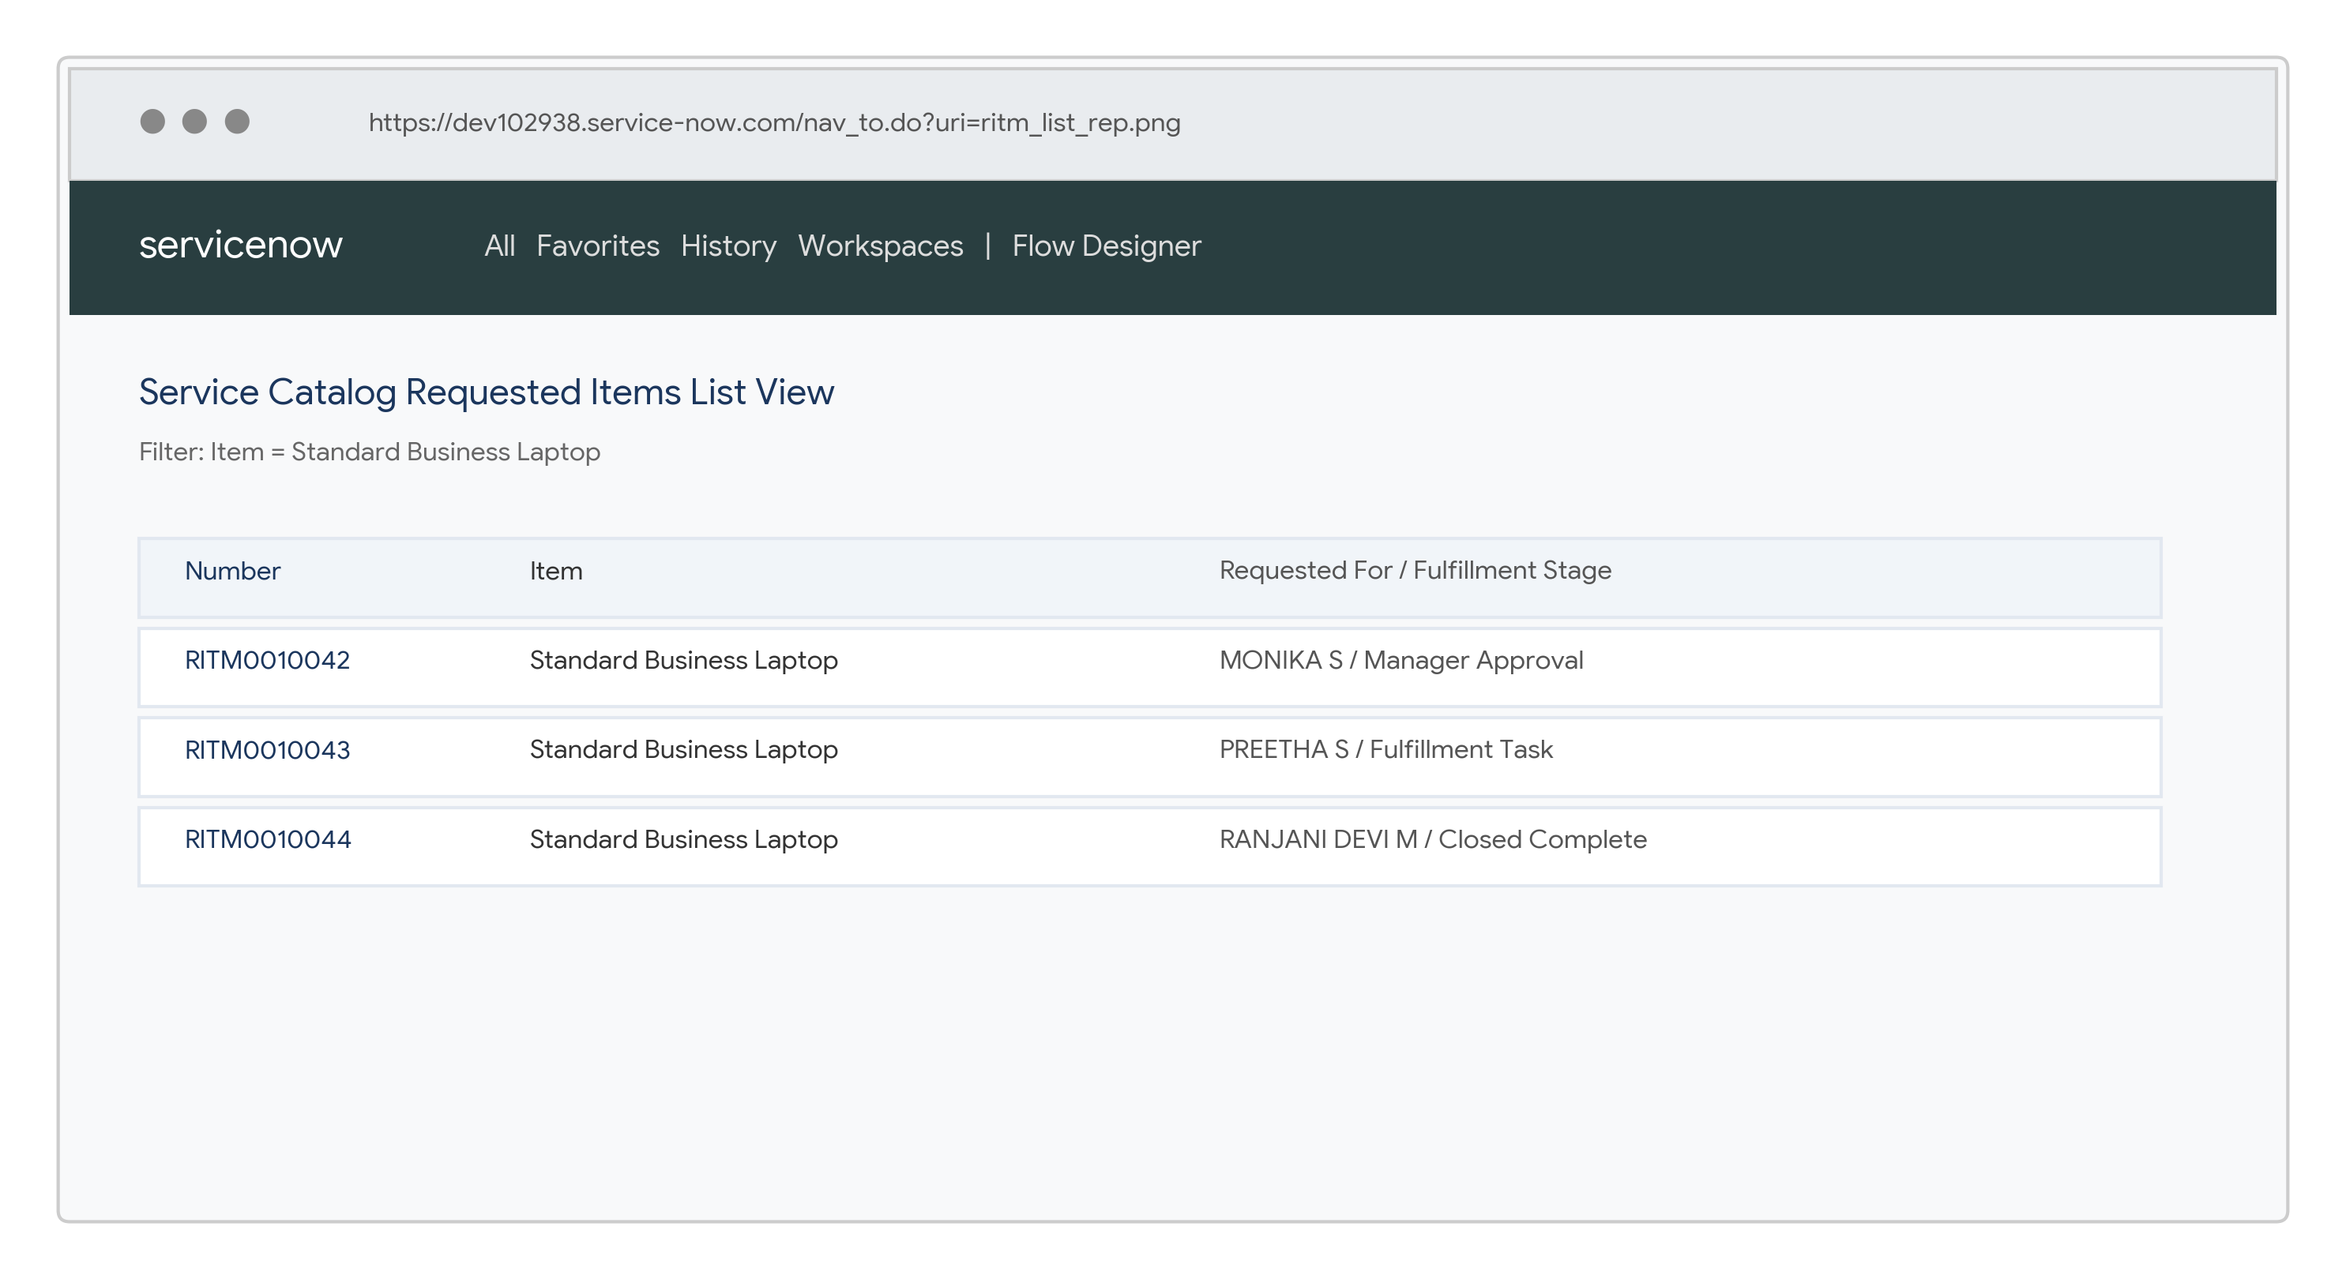
2 | Final Execution Result – Order Approved & Task Assigned

Screenshot Evidence
Screenshot Evidence: This section documents the implementation steps that support the final result. Each screenshot is placed in sequence so that the reviewer can verify catalog creation, requested items preparation, Flow Designer configuration, stock evaluation condition, script action step, and final execution result.
A. Source Code
Actual ServiceNow Flow Designer script used in the Advanced Action step:
(function execute(inputs, outputs) {
var grAsset = new GlideRecord('alm_hardware');
grAsset.addQuery('model.name', 'CONTAINS', 'Dell Latitude 5440');
grAsset.addQuery('install_status', '6'); // In Stock
grAsset.query();
if (grAsset.next()) {
outputs.stock_available = true;
outputs.serial_number = grAsset.serial_number.toString();
} else {
outputs.stock_available = false;
}
})(inputs, outputs);
B. GitHub & Project Demo Link
GitHub Repository: https://github.com/Moni5467/Streamlining-IT-Procurement-Automating-Standard-Laptop-Orders-with-Flow Designer
Project Demo: https://drive.google.com/file/d/10ZCQpUpZyN8Q8C6Leb9ulHTSry6-V0Mo/view?usp=drivesdk
C. Screenshot Evidence
Attach final screenshots showing the target list, Flow configuration, test order and execution result.
1. Table Creation / Catalog Item – Standard Business Laptop
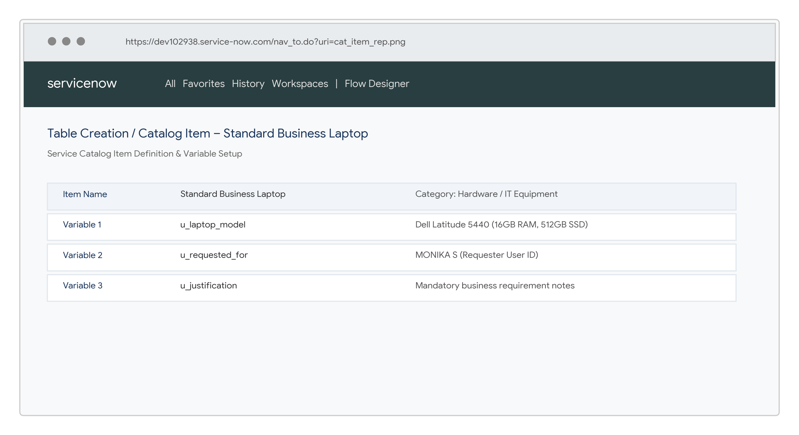
2. Laptop Order Requested Items List View
3. Flow Designer Trigger & Step Configuration
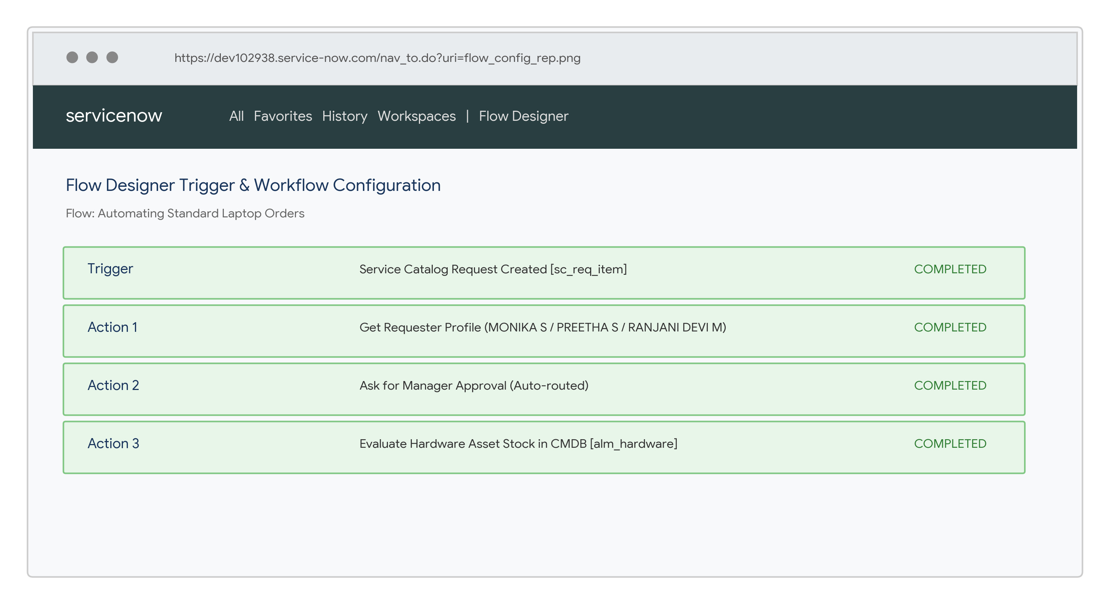
4. Flow Condition – Hardware Stock Evaluation in CMDB
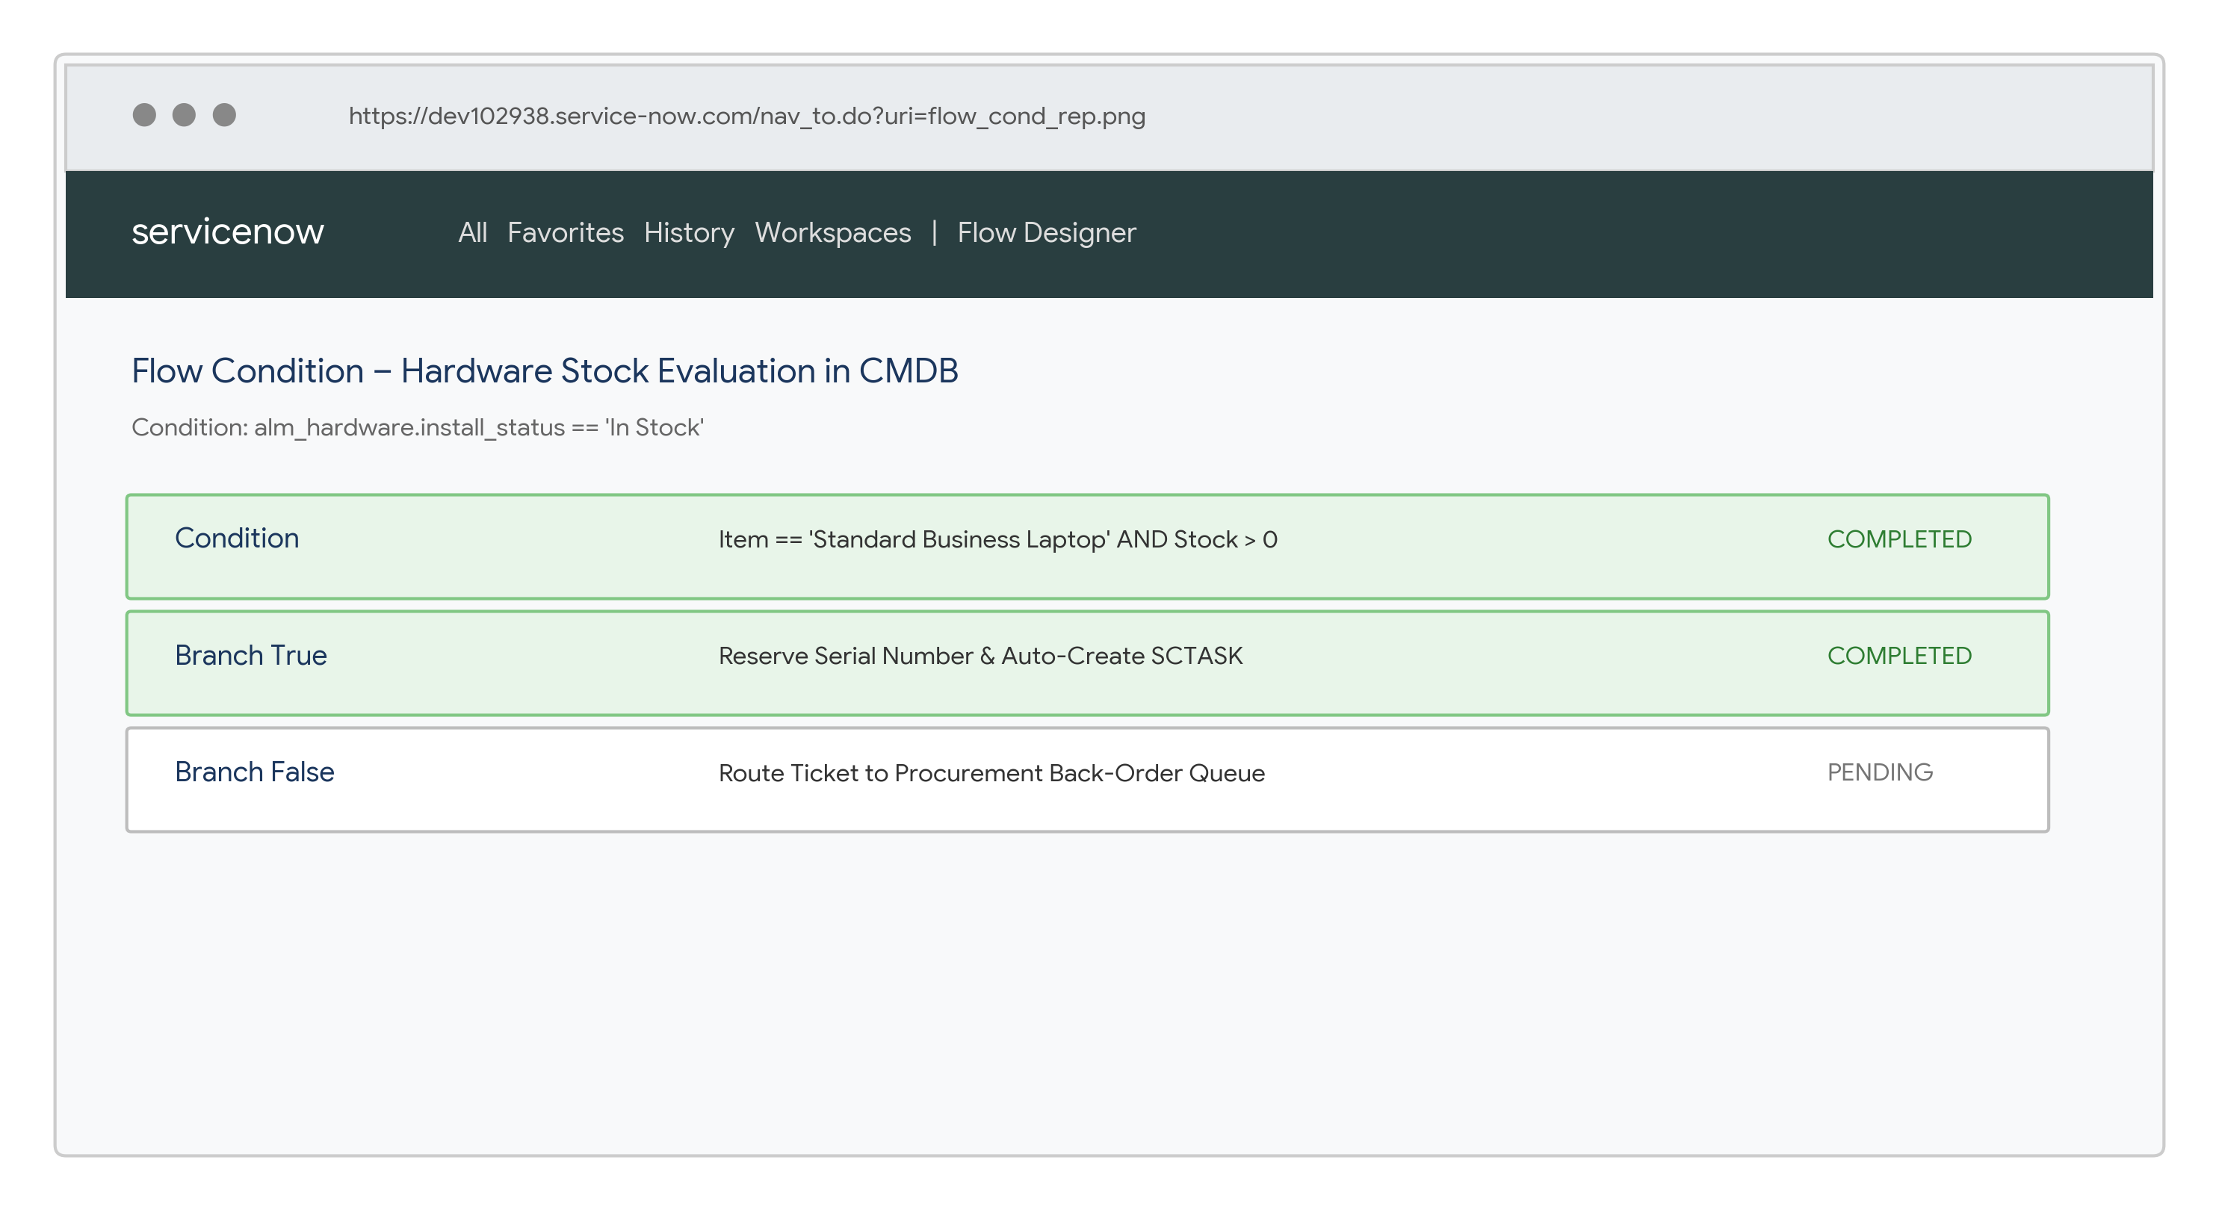
5. Advanced Flow Script Step & Manager Approval Routing
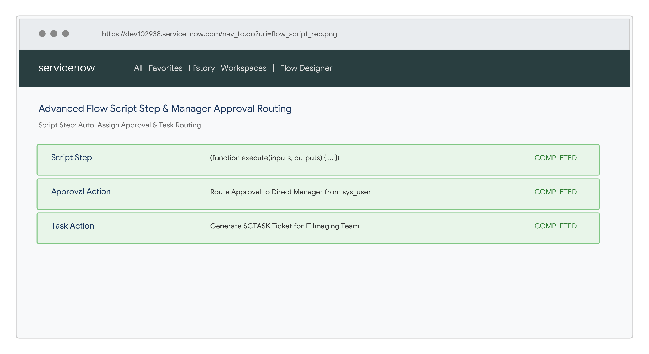
6. Final Execution Result – Task Assigned to IT Team

